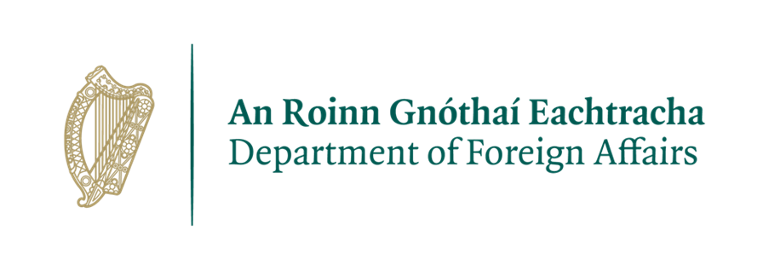**VACANCY - Driver**

**Embassy of Ireland, Abuja**

**Closing Date: 1st December 2023**

***Our mission is to promote and protect abroad the values, interests and economic well-being of Ireland and its people. We do this under the political direction of our Ministers, through our staff at home and through our Embassy network abroad.***

The Embassy of Ireland, **Abuja** is seeking a highly motivated, reliable and hardworking person with excellent communication and interpersonal skills to fill a full-time **DRIVER** position on an initial 12-month contract.

**Roles and Responsibilities:**

The successful applicant will be responsible for Embassy transport and associated logistic and administrative tasks. The precise range of duties will be outlined by the Head and Deputy Head of Mission and will include, but not be limited, to the following:

* Driving members of the Embassy’s staff and their dependents;
* Vehicle maintenance;
* Keeping track of mileage, fuel, and toll expenses;
* Assisting with Embassy events - transporting and loading equipment as required;
* Daily collection/delivery of post; managing the dispatch of diplomatic letters, or other errands;
* Assisting with other administrative duties as needed;
* Carry out other tasks as requested by the Ambassador and Deputy Head of Mission.

**Essential Requirements - candidates must be able to demonstrate:**

* A clean and current driving licence;
* At least 5 years minimum professional driving experience at executive level;
* Completion of official armoured vehicle driving training;
* Fluent English;
* A comprehensive geographical knowledge of Abuja and the surrounding region;
* Evidence of flexibility, efficiency and effectiveness showing strong organizational skills, attention to detail, ability to work under pressure and to manage multiple tasks;
* Examples of being solutions-oriented, and committed to delivering results, including by adapting approach if necessary;
* Experience in providing excellent judgement and decision-making skills;
* A high level of discretion;
* Excellent punctuality and time management skills;
* Availability to work out-of-hours and additional hours, as required;
* All applicants must have a permanent legal right to reside and work in Nigeria.

**Desirable Skills and Experience:**

* Previous relevant experience working with an Embassy or international organisation.

**Terms and conditions of employment:**

* The successful candidate will be hired on a fixed-term contractual basis (initially on a 12 month contract) and will be based in Abuja.
* Working patterns include on-call shift work and work on weekends and holidays, with additional allowances for out-of-hours duty.
* The salary for the position is ₦202,852 monthly gross salary (net ₦176,198). ₦2,637,080 per annum, paid locally on a monthly basis. Salaries are paid direct to a bank account, therefore, the successful candidate must have a bank account.

**How to apply**

The Job Description and Application Form for this position are available on our website <https://www.dfa.ie/irish-embassy/nigeria/about-us/job-opportunities/>.

**Only application forms will be accepted and reviewed.**

Completed application forms should be sent via e-mail only to abujarecruitment@dfa.ie, with the subject line **DRIVER 2023**.

**Applications must be received before 2pm on 1st December 2023**.

No applications will be accepted after this deadline.

Depending on response rates the deadline may be extended. Please note that only short listed applicants will be contacted.

**Selection Process:**

* Depending on the number of applications received, a short-listing of candidates to be called for a competency-based interview may be undertaken based on the Essential Requirements above.
* It is planned that interviews will be held in December 2023;
* A skills test may be included in the recruitment process;
* A second interview may form part of the recruitment process;
* The successful candidate will have to undergo a Medical / Health Check;
* A panel may be set up depending on the calibre of candidates.

**General Data Protection Regulation:**

All personal information received will be kept in line with GDPR guidelines.

**Security Clearance for Local Staff**

Police security clearance will be sought in respect of individuals who come under consideration for appointment. Enquiries may also be made with the police force of any country in which the applicant under consideration for appointment resided. If unsuccessful, this information will be destroyed. If the applicant subsequently comes under consideration for another position, they will be required to supply this information again.

***Please note that canvassing will disqualify applicants.***

***The Embassy of Ireland, Abuja is committed to a policy of Equal Opportunity.***